Build a spring-rest application with Bluemix and SQL Database service

Introduction
The application uses spring to create RESTful service. It is deployed on IBM Bluemix and uses Liberty profile and SQL Database service.

What you'll need to build your application
List prerequisites here. For example:
- Familiarity with the Java web application development.
- A Bluemix account
- A Github account
- Eclipse with Egit and Cloud Foundry plugin.

Provide the following here:
- The URL to your running app:
- The URL to get your code in Git: https://github.com/surajpmohan/spring.git
  - project name: spring-bluemix-rest

Do not modify the buttons below.
Run the app

Get the code

Step 1. Create an SQL Database service on Bluemix
Create an SQL Database service and name it as sqldb on Bluemix.

Step 2. Execute the DDL statements.
Use Bluemix IBM SQL Database console to upload and execute the /spring-bluemix-rest/resources/contact.sql

Step 3. Create a Dynamic Web project using eclipse.
Create a dynamic web project using eclipse.
Select the target runtime as Cloud Foundry.

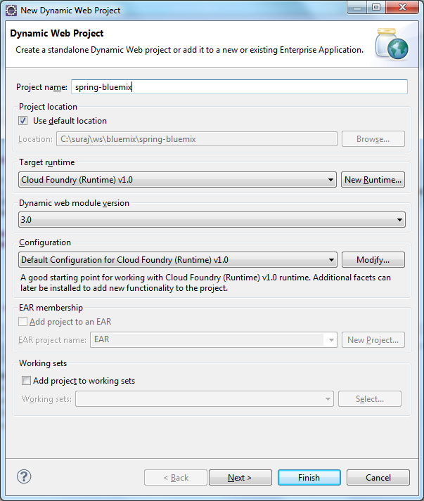

Step 4. Write the code.

Get the code from https://github.com/surajpmohan/spring/tree/master/spring-bluemix-rest and copy into the eclipse project.

Step 5. Deploy and run the application on eclipse.
While deploying the application link the project with sqldb service.
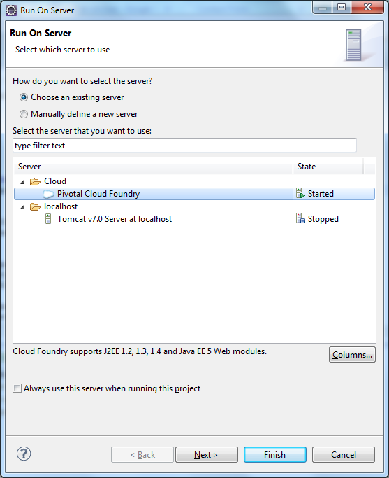

Conclusion

